**VR technology Lab III Report**

Name: Dazhi Li

RUID: 197007456

YouTube Link: <https://youtu.be/uPhnphMq9WE>

3-D sound YouTube Link: <https://youtu.be/wfi5YUZd4Rg>

1. Abstract

My choice is option A in this lab project. I designed and built a country house with a small soccer court in its garden to make a few things interactive. There are many hard points like how to write a C# code to interact with those objects in my scene and how to import blender projects with textures on it into Unity, etc. I will explain how I achieve in later sections and here is a brief view of my designed country house.

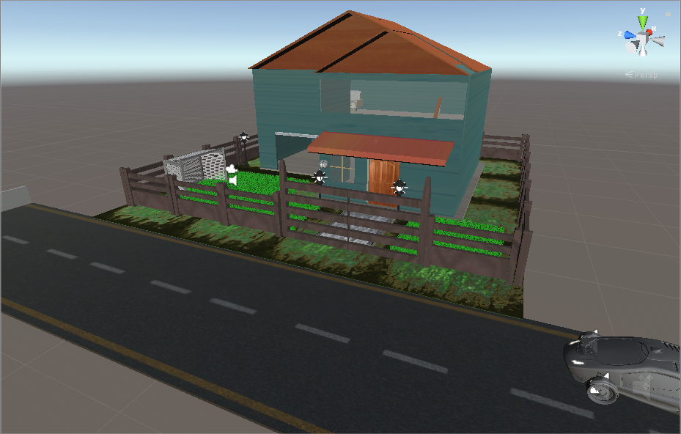

Figure 1

1. Requirements

There are too many requirements in this lab so I am going to assign some sub-part as a big paragraph in this report in part 3 – 7 and some small sub-part still in paragraph 2.

1. First-person controller character

This a very easy problem we can import this from unity’s standard assets for user to walk around in unity world. And there is nothing special in this lab specified in this part.

1. Rigidbodies and Use of physics engine

Ragidbodies is widely used in this lab since we want to give out objects realism. Rigidbody is a component that gives object mass, gravity and even collider. I use ragidbodies in my country house door and door wall which is kinematic. And those soccer. Door rigidbody in **figure 2-1**.

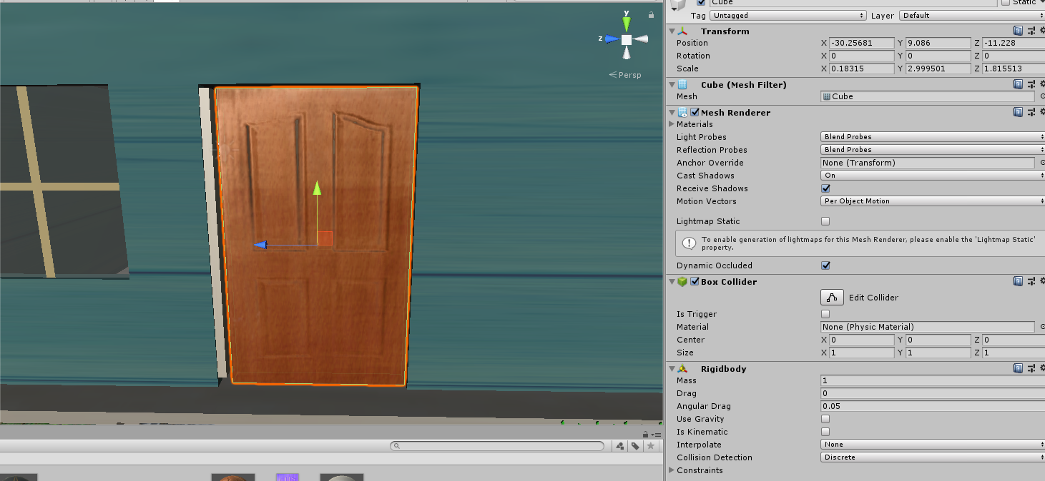

Figure 2-1

Physics engine are used on my soccer which is bounceable and could be interactive with FPC’s collision. The key point of using a physic engine is setting the right physical material on an object which is shown in **figure 2-2**

Figure 2-2

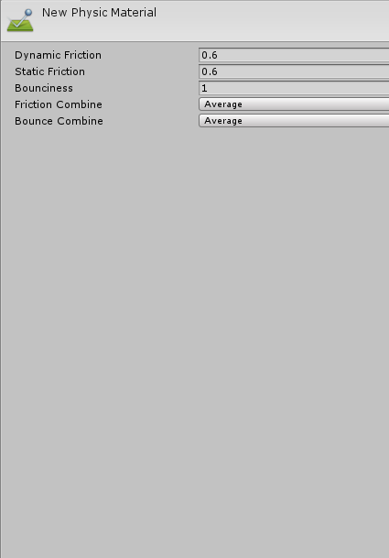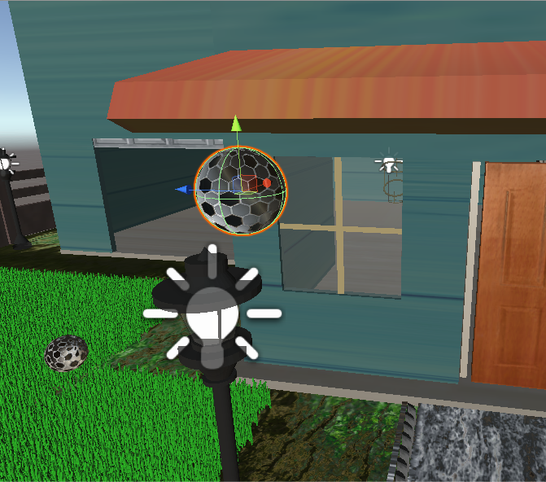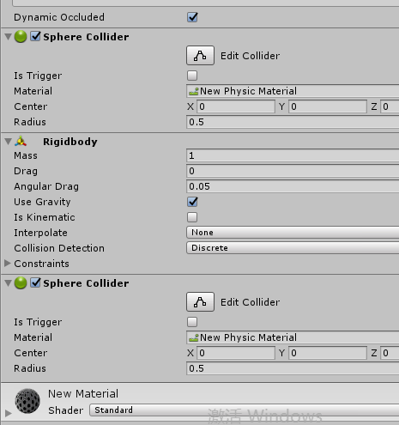

1. 3-D Audio

Since what we have learnt from the classes of VR technology we understand there is totally difference between 3-D sound and stereo sound. What we are going to achieve from 3-D sound is that, by moving our FPC, we could deduce approximately where the sound source is and sound volume changes arose by location change. I design a car which will create noise when it is moving to create 3-D sound effect.

Although it is not very realistic but it is still good for user to tell where the car it is. By the way, the car is the only prefab I got from the unity asset store.

1. More than 5 Unique models created in Blender

Figure 2-3

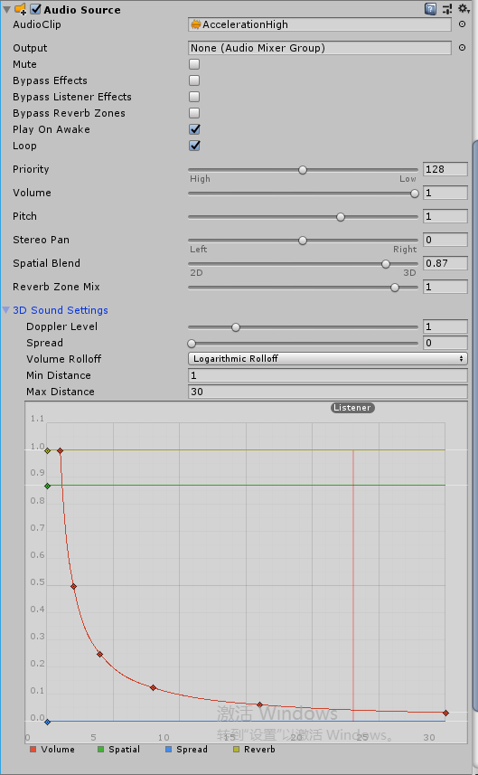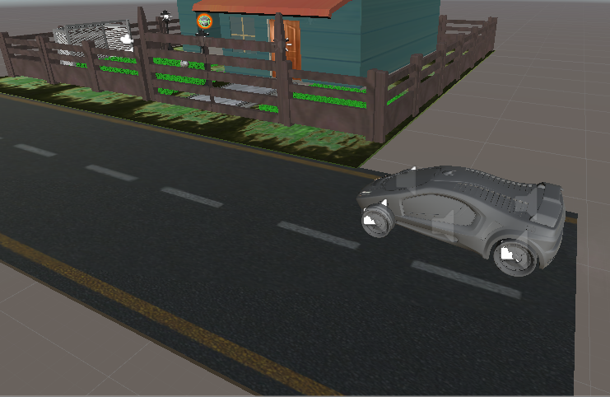

1. House

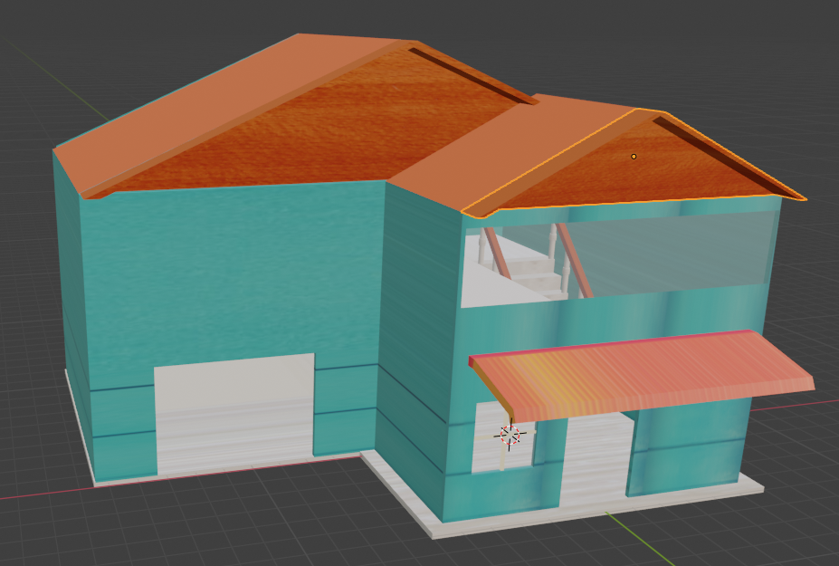

Figure 3-1

1. Fence and Fence Door
2. Grass

Figure 3-3

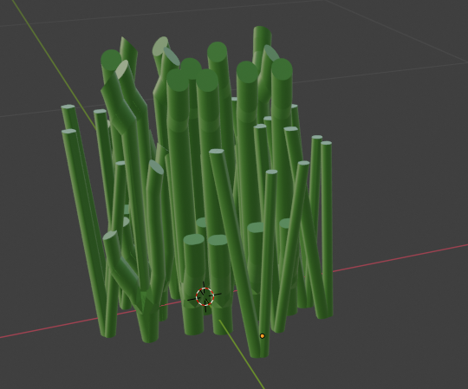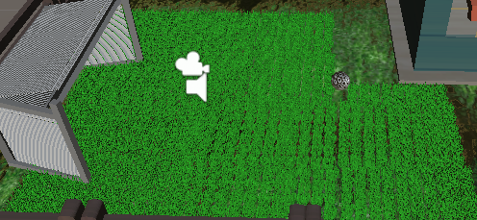

Figure 3-2

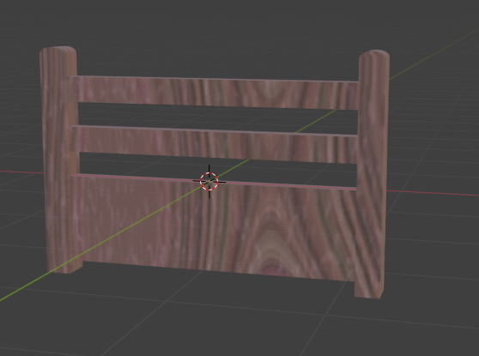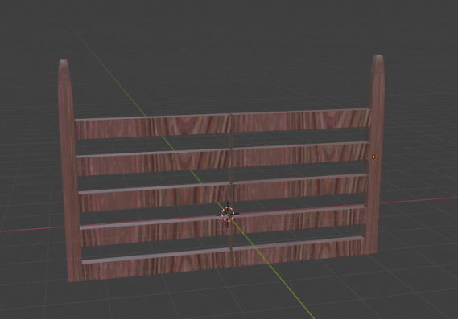

1. 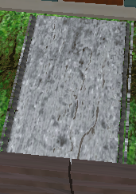Stone road

Figure 3-4

1. 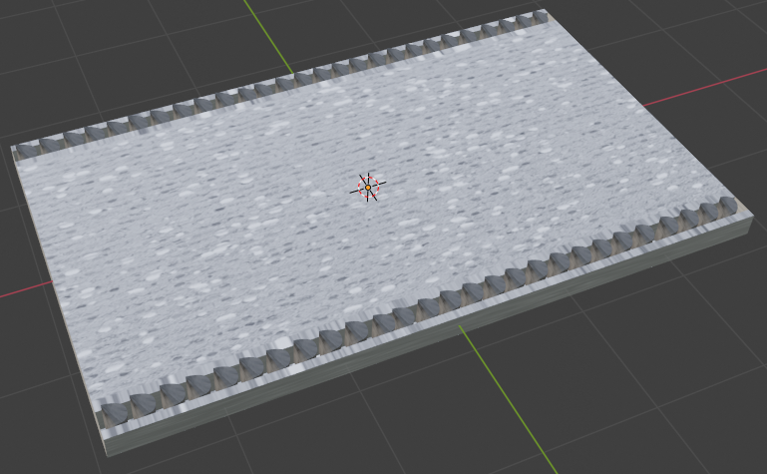Lamp

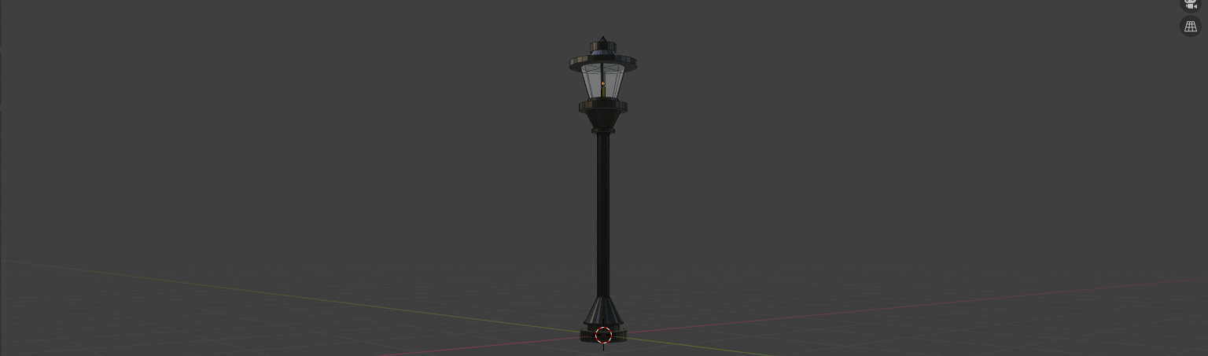

Figure 3-5

1. Hanged lights

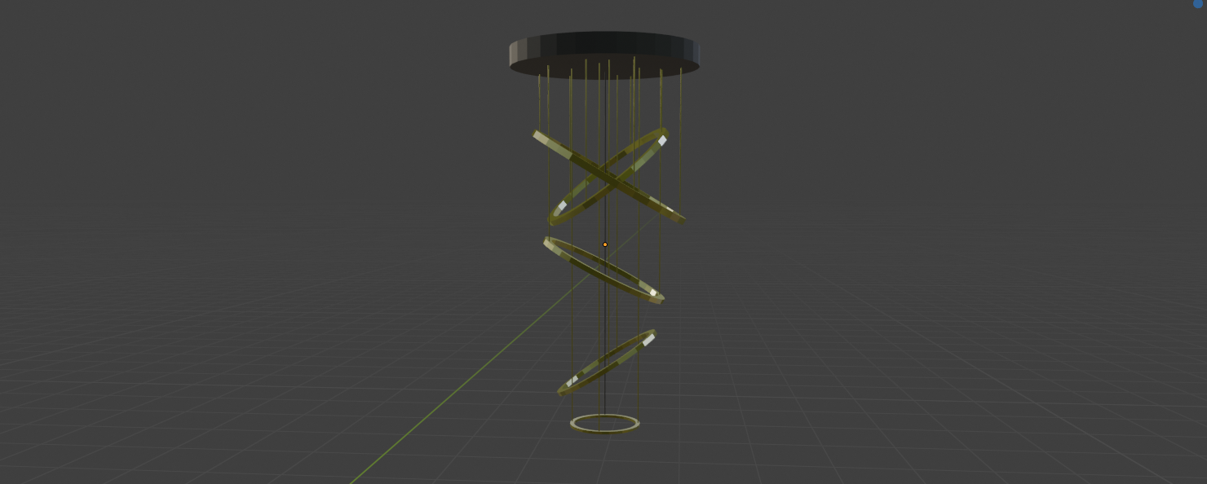

Figure 3-6

1. Soccer gate

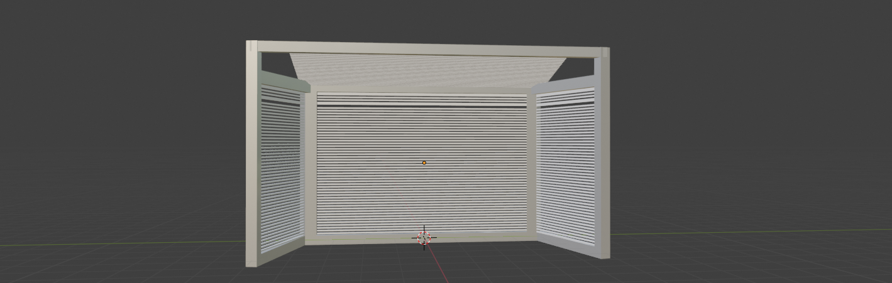

Figure 3-7

1. Lighting

Light setting are achieved by the environment light intensity adjustment and lamp point light, also indoor hanged lights. The point lights for street lamp are shown in **figure 4-1**. Point light for hanged light are shown in **figure 4-2**. The environment light from the skybox could be easily set like I have written before in Lab 1 report so I am not going to talk about this anymore.

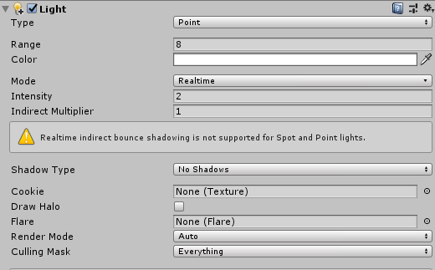

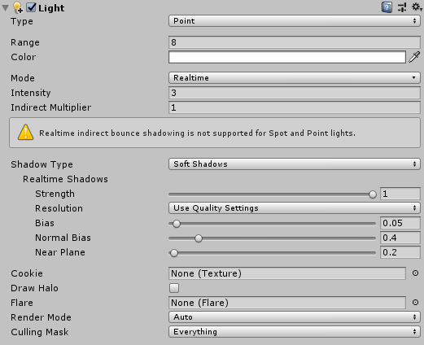Figure 4-1

Figure 4-2

1. Texture and normal mapping

There are many places where texture and normal maps are utilized so I will just give some typical example on how to manipulate on texture and normal map in my lab 3 project. I am going to take the garage door as an instance. As we know the garage is a cube actually, but normal cube will not make the garage rough and like a metallic door. The normal map will help user to see those rough detail.

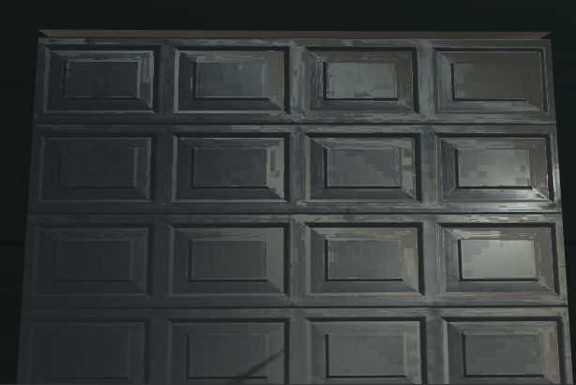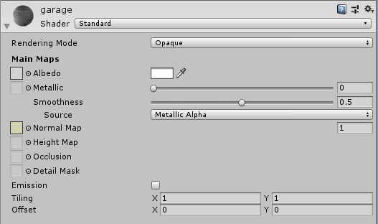

Figure 5

1. Two Unique Scripts

There are totally two unique scripts in my lab scene and you can see my YouTube video of how it works. The code are shown below. The first code is moving a car from one side of street to another side. When it collide with other objects the car will automatically stop and shut down its ignition.

public class Translate : MonoBehaviour

{

public float speed = 1.0f;

private AudioSource mSound;

void Awake()

{

mSound = GetComponent<AudioSource>();

}

void Update()

{

transform.Translate(Vector3.forward * Time.deltaTime * speed);

}

void OnCollisionEnter()

{

speed=0;

mSound.Stop();

}

}

Another unique transcript is rotating the wooden fence door, it is achieved by rotate around out center of an object.

public class Rotation : MonoBehaviour

{

Vector3 TARGET = new Vector3 (-3.625561f,0.9956227f,-5f);

public float rotation=1.0f;

void OnGUI()

{

transform.RotateAround(TARGET,Vector3.up,rotation);

}

}

1. [Advanced] 3 unique objects with unique animations

These 3 unique objects which can be interacted with FPC is hard to use picture to show examples, I recommend you to watch my YouTube video and here I will just give some basic ideas of those 3 objects.

1. Soccer

I place a soccer on the grass field, the first stage interaction is rotating the ball. The second state is kicking the ball into the soccer gate.

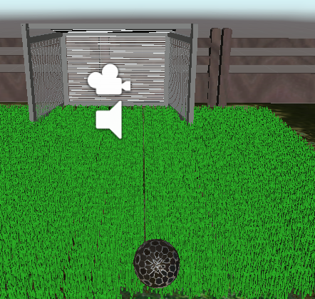

Figure 7-1

1. Garage Door

The garage door can be manipulated to go up or down. There are two stages, each stage is an animation. The garage has already been shown in **Figure 5**.

1. TV protectors

The TV protectors will cover something like a fibric on the screen of the television. By clicking on one side of the TV protectors, the fibric will shrink/expand and show/cover the TV.

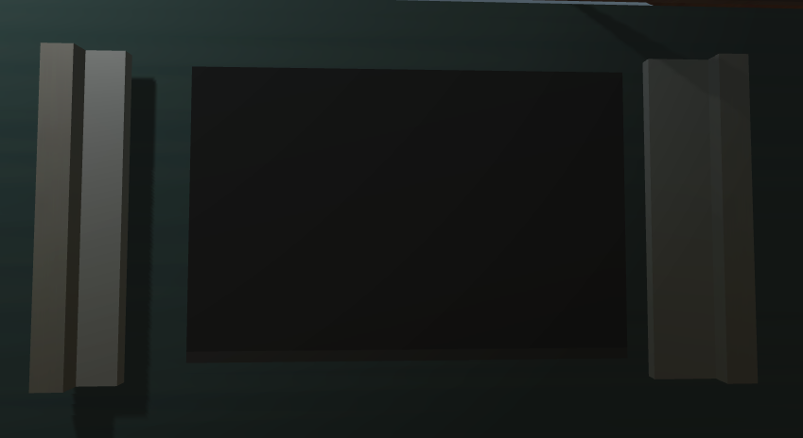

Figure 7-3

1. Conclusion

From this lab I learnt how to do unity animation and how can we set up a trigger in unity to animate scenes. Also, by using C# scripts will help us improve the interactive ability of unity to users. Finally, physical engine could bring more realistic scene to us.